The paper **3D LIDAR Point Cloud based Intersection Recognition for Autonomous Driving**, written by Quanwen Zhu, Long Chen, Qingquan Li, Ming Li, Andreas Nüchter and Jian Wang proposes a new model for the real-time detection of road intersections for moving autonomous vehicles. It is a new approach toward remote sensing to improve navigation and path planning in autonomous vehicles. The data used in this model are from the high-end LiDAR sensor Velodyne HDL-64ES2 which provides point cloud data of the car at many frames per second. The algorithm for this model of Beam-Based feature construction is as follows:

A. Data Processing:

* Each frame of the point cloud is used to create a grid map
* Calculate variance of elevation for each cell of the grid
* Run a thresholding process at a given threshold value to set the variance of elevation either as 1 or 0
* It now forms a 2D image
* Now form a grouping of cells by traversing through each cell of the grid
* Rebuild these connected cell regions to surround a cube.
* Using length and height of the cube detect other vehicles and pedestrians and remove those cells from the grid map.

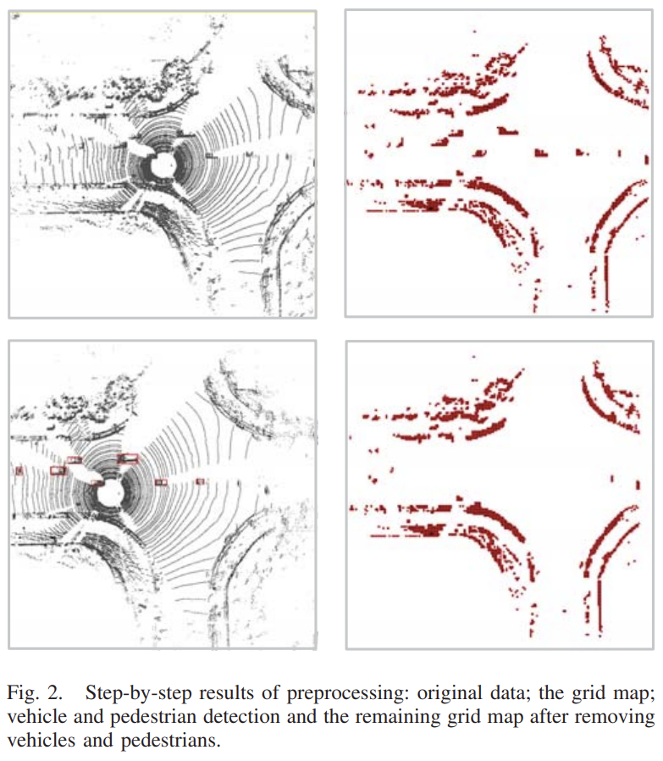

* The beam model is launched in front of the vehicle at a distance related to the speed of the vehicle (e.g., D=5+v*t)
* The beam model consists of 360 beams with a 1-degree angle difference between each of them and has a width slightly bigger than the width of the car.
* When the beam is cut off by an obstacle its length is measured.

If it is not cut off its length is limited to a constant.

* A histogram graph is plotted with the normalised length of each beam vs its angle.
* The number of peaks in the histogram give us the number of openings in the road. Thus, enabling us to classify whether it is a +-shaped pr T-shaped intersection.
* The classification is done by using a machine learning algorithm. Here we have used a Support Vector Machine (SVM) as our classifier.

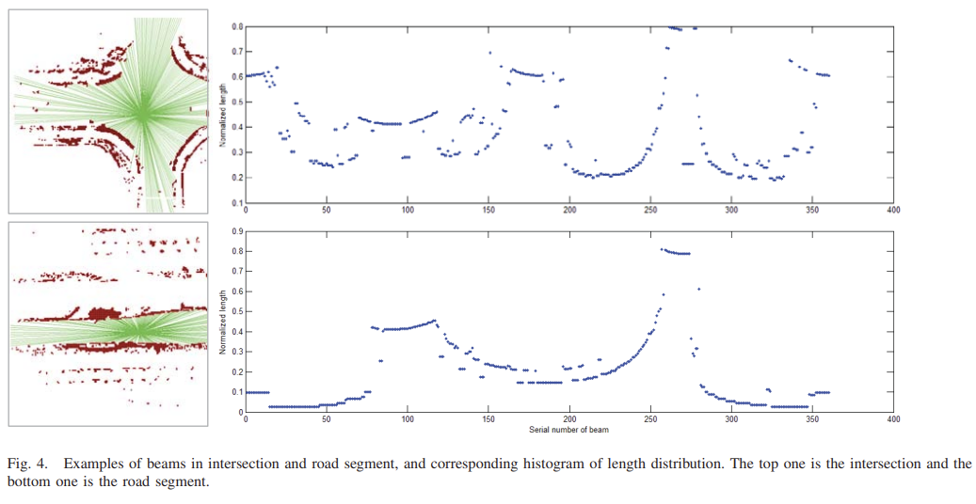B. Experiments and results:

To verify the effectiveness of this method experiments are done applying this algorithm to different data and analysing the accuracy of the prediction. Different data sets from different road types, different levels of interference from pedestrians and other vehicles are used for this purpose and their corresponding ROC curves, TPR, TNR, AUC, and other parameters are noted when predicting the intersection type. The data from these predictions are as shown.

* Intersection and road segment classification

|  |  |  |  |  |
| --- | --- | --- | --- | --- |
|  | TPR | TNR | Accuracy | AUC |
| Test Data 1 | 91.25% | 96% | 93.625% | 0.987 |
| Test Data 2 | 81% | 84% | 82.5% | 0.938 |

* T-shaped and +-shaped intersection classification

|  |  |  |  |
| --- | --- | --- | --- |
|  | TPR | TNR | Accuracy |
| Test Data 1 | 93.382% | 80.681% | 85% |
| Test Data 2 | 85.714% | 79.545% | 83% |

Insights:

* The accuracy in the predictions are pretty good but it far from being a perfect machine for autonomous vehicles. Because we are dealing with vehicles on the road with numerous lives affecting from the incidents. Even a small computational inaccuracy could lead to a major accident and cause harm to human lives.
* On the other hand, the number of accidents due to human error is huge and a safer, more efficient autonomous system like this one could help reduce the number of accidents on a greater scale.
* Here we have used detecting the variance of elevation from point cloud data of LiDAR to detect other cars and pedestrians. We could implement sensor fusion techniques of LiDAR and cameras or LiDAR and RADAR to detect them with higher accuracy.
* A higher-end beam model with more than 360 beams could be used to get more data and increase the smoothness of the histogram.
* Since this is a LiDAR based system its production, installation and transportation would be expensive.
* We could launch the beam models at multiple launch points to get more data and combine the results for better accuracy.
* We could implement the new ideas in this model like giving width to the beam model and the adaptive launching distance concepts to the other notable models mentioned in the paper and see if we come up with a model with better accuracy.
* We could also use this model to detect other attributes of intersections of road such as direction and width.
* On a more ambitious scale, if we had enough autonomous vehicles with this system installed, we could upload the data from each vehicle to a cloud system and integrate them with each vehicle and provide much more info and thus increase the accuracy multiple-folds.